Zorba Interview Questions
Technical Questions

- What is the difference between serialization and de- serialization on java?
https://www.scaler.com/topics/java/serialization-and-deserialization/
Serialization in simple terms means converting an object into a sequence of bytes, deserialization is exactly the opposite. In deserialization, an object is reconstructed back from the sequence of bytes.
To add the serializable behavior to our class, we shall take the help of a marker interface called Serializable, which is a part of the java.io package.
So basically, for writing objects into a stream, we have the ObjectOutputStream Class in Java. This is possible only if the class implements a serializable interface, and thus the objects can be passed as arguments to the methods of ObjectOutputStream Class.
Relating to the phone call case, when data in Java (or Java objects, as it is an OOP language) travel from one interpreter( or Java Virtual Machine) to another, several conversions occur. These are mainly serialization and deserialization.
Deserialization is the opposite of serialization. It is exactly the reverse process. So, to define deserialization, it is the process of converting a stream of bytes to the original state of the object. To perform deserialization, Java provides the ObjectInputStream class, which is again opposite to the ObjectOutputStream we studied for serialization.
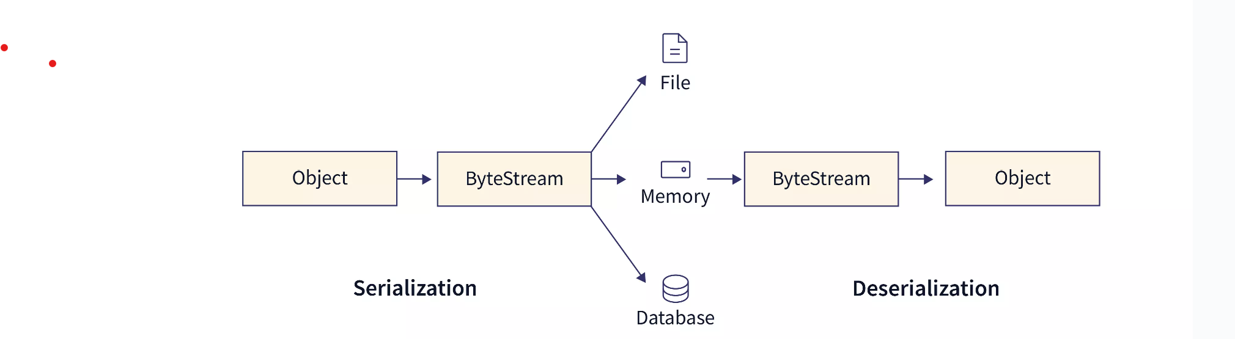

One thing to note here is that the byte stream is platform-independent, which means after serializing the object on one platform, it can be converted back to the original state on any other platform.

2 . Define method overloading and find the invalid code on the piece of code he gave?
If a class has multiple methods having same name but different in parameters, it is known as Method Overloading.
Example:1
Suppose you have to perform addition of the given numbers but there can be any number of arguments, if you write the method such as a(int, int) for two parameters, and b(int ,int, int) for three parameters then it may be difficult for you as well as other programmers to understand the behavior of the method because its name differs.
Example:2
Suppose, you have to perform the addition of given numbers but there can be any number of arguments (let’s say either 2 or 3 arguments for simplicity).
In order to accomplish the task, you can create two methods sum2num(int, int) and sum3num(int, int, int) for two and three parameters respectively. However, other programmers, as well as you in the future may get confused as the behavior of both methods are the same but they differ by name.
The better way to accomplish this task is by overloading methods. And, depending upon the argument passed, one of the overloaded methods is called. This helps to increase the readability of the program.

3. Why you prefer selenium for automation?
- multi browser support – chrome, safari, IE
- Parallel testing- two application testing at a same time
- Reusability of code
- Support across the various operating systems- mac, Linux, window

An alternative to selenium:
- Cypress
- Cucumber
- Robot framework
- Protractor
https://www.knowledgehut.com/blog/software-testing/selenium-vs-cucumber-difference
https://www.browserstack.com/guide/top-selenium-alternatives
https://www.browserstack.com/guide/cypress-vs-selenium
https://www.testim.io/blog/protractor-vs-selenium-detailed-look-at-how-they-compare/#:~:text=Selenium%20can%20replicate%20user%20actions,server%20testing%20on%20the%20cloud.
https://www.educba.com/robot-framework-vs-selenium/
https://www.geeksforgeeks.org/robot-framework-vs-selenium/

4. Have you got the chance to create the framework from the scratch?
Ans: No. I have not done Myself on my own. In our company we have different team specially for creating the framework. The framework template will be provided, and we will work on IT.
Ans: Yes.

5. Difference between TestNG and Junit and which one you prefer and why?
https://www.toolsqa.com/testng/testng-vs-junit/
JUnit is a testing framework written in Java. Moreover, JUnit is used for unit testing in Java and gets its name from the combination of Java + unit testing. it is beneficial for the tester to write and execute repeatable automation tests. The framework is very popular in the testing community today. Moreover, for writing the automation tests for the web, JUnit is used quite extensively with the Selenium web driver.
In Junit, Once you are done with the code, you should execute all test and it should pass . Every time any code is added you need to re-execute all test cases and make sure nothing is broken.

The TestNG framework was released after JUnit and served the same purpose, along with some additional functionalities. Additionally, the TestNG framework is used for testing and written in Java for the Java programming language. The JUnit and NUnit frameworks inspired the TestNG framework and covered a vast area in testing. Moreover, the TestNG framework performs unit testing, end-to-end testing, integration testing, etc.
Using TestNG you can generate proper report and you can easily come to know how many test cases are passed, failed and skipped. You can execute the failed test cases separately.
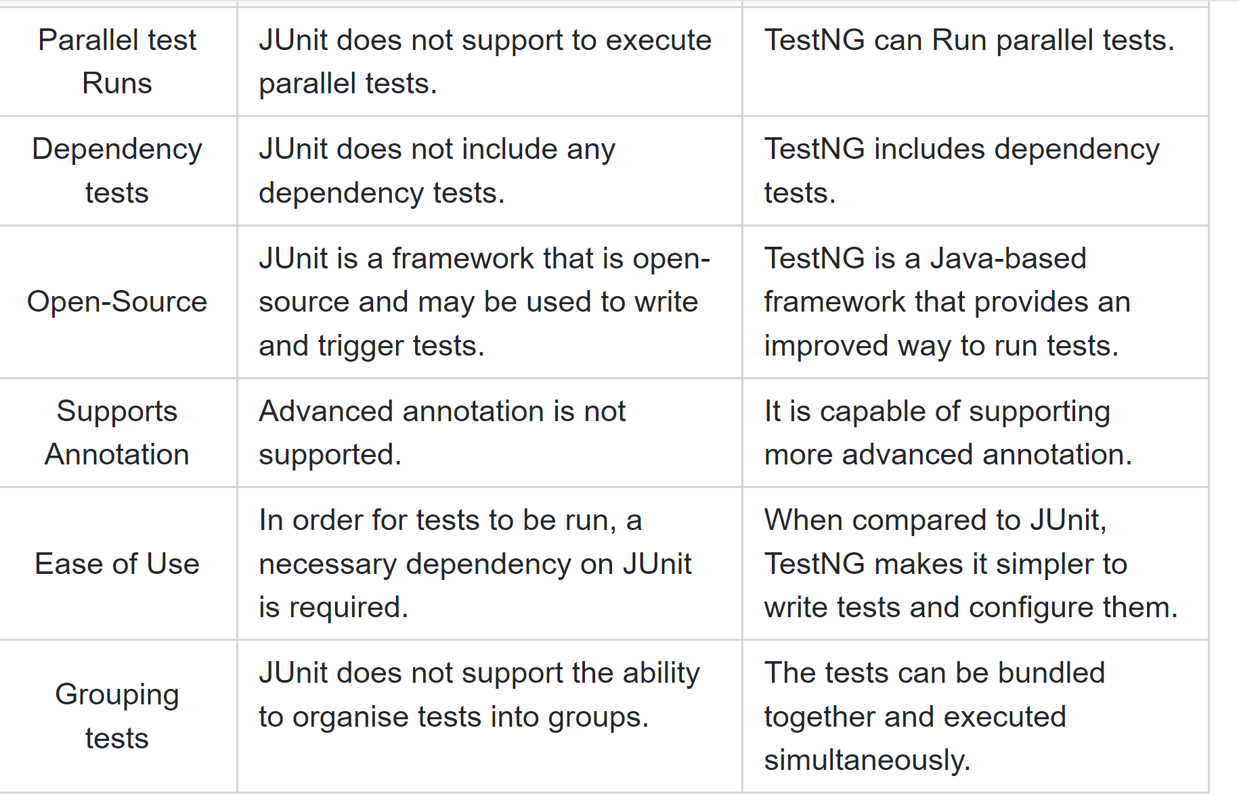

7. What is autoIT that is on my resume tell me more about it?
https://www.softwaretestinghelp.com/autoit-tutorial-to-download-write-autoit-script/
AutoIt is a freeware scripting language designed for automating windows GUI and general scripting. It uses a combination of mouse movement, keystrokes and window control manipulation to automate a task which is not possible by selenium webdriver.

8. How do you manage the waiting time on selenium ?
https://www.softwaretestingmaterial.com/selenium-wait-commands/
https://www.browserstack.com/guide/wait-commands-in-selenium-webdriver
https://www.tutorialspoint.com/make-selenium-wait-10-seconds

While executing scripts, sometimes we may face an exception “Element Not Visible Exception“. This exception appears when there is a delay in loading time of the elements which we are interacting. To overcome this issue we need to use Wait Commands. Using the Selenium Wait Commands, our script will wait for the elements to load for certain time before continuing with the next step.

- Principal of agile

Satisfy Customers Through Early & Continuous Delivery

Welcome Changing Requirements Even Late in the Project

Deliver Value Frequently

Break the Silos of Your Project

Build Projects Around Motivated Individuals

The Most Effective Way of Communication is Face-to-face

Working Software is the Primary Measure of Progress

Maintain a Sustainable Working Pace

Continuous Excellence Enhances Agility

Simplicity is Essential

Self-organizing Teams Generate Most Value

Regularly Reflect and Adjust Your Way of Work to Boost Effectiveness
https://kanbanize.com/agile/project-management/principles

4. When you sent error or bad code which response will you get?
https://umbraco.com/knowledge-base/http-status-codes/
=➔400
Q. Have you ever done API testing? How do you do the automation and manual API testing?
Yes, I have done API testing. Manual and Automation API testing follows the same Software testing Lifecycle as others testing.
It does:
- Requirement analysis
- Test Panning
- Test Case Development
- Environment Setup
- Testcase execution and
- Test Closure.
For APl testing tools:
SoapUI, Postman, Apache JMeter, Apigee, Rest Assured, Swagger UI, Katalon.
Mostly I have used, Postman for manual API testing. I have used postman to manually test restful APIs.
A test in Postman is fundamentally a JavaScript code, which run after a request is sent and a response has been received from the server.

We go ahead and request different methods like GET, POST, PUT, DELETE, etc. We transfer data in JSON format. (Manual testing tool)
For Automation API testing I have use Rest Assured. Rest-Assured is a Java-based library that is used to test RESTful Web Services. This library behaves like a headless Client to access REST web services. We can create highly customize-able HTTP Requests to send to the Restful server. This enables us to test a wide variety of Request combinations and in turn test different combinations of core business logic.
https://www.toolsqa.com/rest-assured-tutorial/
Have you ever used TestNG?
-yes.
What are different annotations in TestNG?
https://www.browserstack.com/guide/testng-annotations-in-selenium
- @BeforeMethod: This will be executed before every @test annotated method.
- @AfterMethod: This will be executed after every @test annotated method.
- @BeforeClass: This will be executed before first @Test method execution. It will be executed one only time throughout the test case.
- @AfterClass: This will be executed after all test methods in the current class have been run
- @BeforeTest: This will be executed before the first @Test annotated method. It can be executed multiple times before the test case.
- @AfterTest: A method with this annotation will be executed when all @Test annotated methods complete the execution of those classes inside the <test> tag in the TestNG.xml file.
- @BeforeSuite: It will run only once, before all tests in the suite are executed.
- @AfterSuite: A method with this annotation will run once after the execution of all tests in the suite is complete.
- @BeforeGroups: This method will run before the first test run of that specific group.
- @AfterGroups: This method will run after all test methods of that group complete their execution.

What is assert and verify in java?
https://rahulshettyacademy.com/blog/index.php/2021/05/20/assert-and-verify-methods-in-selenium/
Asserts and Verify methods are commonly used in Selenium for verifying or validating applications.
- When an “assert” command fails, the test execution will be aborted. So, when the Assertion fails, all the test steps after that line of code are skipped. The solution to overcoming this issue is to use a try-catch block.
- When a “verify” command fails, the test will continue executing and logging the failure. Mostly, the Verify command is used to check non-critical things.

What are the different locators in selenium?
Webelement locators
- ID
- Name
- Linktext
- Partial Linked text
- DOM
- XPATH
- CSS
- Tag Name etc

Have you done end to end, functional testing? Give some examples.
Example:1
For example consider a situation where you login into your bank account and want to deposit some amount to another bank account which becomes third party subsystem. You follow the below steps
- Logging into the bank system
- Check the balance amount
- Deposit some money to another bank from your account
- Check your latest balance
- Check out from your account

Example:2
Let's imagine that testers need to confirm that a Gmail account is operational. The following attributes need to be examined:
- To open the Gmail login page, enter the URL into the address box.
- Enter your account using legitimate credentials.
- Access Inbox. Examine your read and unread emails.
- Create a fresh email.
- Respond to and forwarded an email.
- Dispatch the Sent Items folder. Verify your emails there.
- Go to the Spam folder. Verify your emails there.
- To exit Gmail, click the "logout" button.

Example:3
Another example of an E2E test case that tests whether new users can add a product to their cart and buy it through an eCommerce app might look like this:
- Type the URL of the eCommerce site into the address bar and submit
- Find and click a product link on the homepage
- Click on the ‘add to cart’ button
- Verify the ‘view cart’ link appears and click on it
- Navigate through the checkout process and input name, credit card, address and other details
- Click ‘submit’
- Verify purchase succeeded and the user receives an email confirmation

https://www.lambdatest.com/learning-hub/end-to-end-testing#i
https://www.softwaretestinghelp.com/what-is-end-to-end-testing/
https://prodperfect.com/blog/end-to-end-testing/how-to-build-e2e-test-cases/
https://qalified.com/end-to-end-testing/\

Can you write test scripts from scratch?
https://www.tutorialspoint.com/what-is-a-test-script-and-how-do-i-write-one

How to disable the test in TestNG?
https://howtodoinjava.com/testng/testng-disable-ignore-tests/
To disable a test in TestNG, we should set the enabled attribute of the @Test annotation to false. The default attribute value of enabled is true.
Disabling a Test
@Test( enabled=false )

Test Method Level
The following test will be disabled and excluded from the test suite.
@Test( enabled=false )
public void someTest() {
//test code
}

Test Class Level
We can apply the @Test annotation to the class, as well. If enabled attribute is set for the @Test annotation at the test class level, all the tests inside the class will be disabled.
@Test(enabled = false)
public class IgnoreTestDemo {

@Test
public void someTest() {
//test code
}
}

3. Types of testing
Functional (selenium) and non functional
Validation is all about system. We do on system
Verification is document.
Giving the output and verifying the output is functional testing.
To check the certain aspects which is not the system but it is the speed of the system, response of the system, how system response on work load ,data volume (large no. of users). Basically not functional.
There are two types of testing and both should be of validation
- Functional testing: Functional testing is the stage in the software delivery life cycle in which the quality engineers verify whether the application under the test’s feature behaves as per their requirement or not.
Types of Functional testing:
Unit Testing: Unit testing involves the testing of each unit of the software application. The purpose of unit testing is to test the correctness of isolated code. It is usually done by the developers. For eg: Let’s take the example of the travel booking website. We can navigate to the homepage. We can see several individual units, such as the search flight button, the book now button, and multiple filters. All these have individual code units, which developers test separately before placing them on the homepage for the users.
Component Testing: It is used to test all the modules/components separately. In the component testing, all the components or modules are required to be in the individual state and manageable state. For eg: Let’s take an example of sign in page of a travel ticket booking website. Let’s call this page C1. If we navigate to the website signup page, it’s another component of the same application. Let’s call it C2. C1 and C2 are made of various code units working together to make the login and signup components functional, making up the application under test (AUT). Before moving ahead with testing C1 and C2 together (after integration), developers will separately analyze these two components. Individually, C1 and C2 must function as per the requirement with a set of inputs.
Smoke Testing/Confidence Testing/Build Verification Testing/Day 0: It is one of the software testing method that is used to determine if a new software build is ready for the next testing phase. It reduces testing time because testing is done only when the key features of the application are not working or if the key bugs are not fixed. In smoke testing, we verify every build is testable or not; hence it is also known as Build Verification Testing. It is just like testing general or overall features of build software.
Sanity Testing: It is done to check the new functionality bugs have been fixed. The execution of sanity testing makes sure that new modifications don't change the software's current functionalities. It also validates the accuracy of the newly added features and components. It is just like the checking up specific part of the software.
Integration Testing: In this type of testing, modules are first tested individually and combined to make a system. This is tested in group. This testing is executed by the testers. It is that type of testing to check if different features of the modules are working together correctly or not. For eg: mobile banking applications has to be synced with one module to another.
There are two type of Integration Testing. Those are: Incremental Integration Testing and Non Incremental Integration Testing(Big Bang Method). Incremental Integration Testing are further divided into three types: Top Down Integration Testing, Bottom up Integration Testing and Sandwich Integration Testing (Hybrid Integration Testing)
System Testing: It means testing the system as a whole. All the modules/components are integrated in order to verify if the system works as expected or not. System Testing is done after Integration Testing. This plays an important role in delivering a high-quality product. The process of testing is done as an integrated hardware and software system to verify that the system meets its specified requirements.
If an application has three modules A, B, and C, then testing done by combining the modules A & B or module B & C or module A& C is known as Integration testing. Integrating all the three modules and testing it as a complete system is termed as System testing. In system testing, more than 50 type of testing are done.
Acceptance Testing: It verifies whether the software is conforming specified requirements and user requirements or not. User acceptance testing (UAT) is a type of testing, which is done by the customer before accepting the final product. UAT is done by the customer (domain expert) for their satisfaction, and check whether the application is working according to given business scenarios, real-time scenarios. It does not focus on customer errors, spelling mistakes.
Regression Testing: It is the last type of functional testing. Regression testing is making sure that the product works fine with new functionality, bug fixes, or any change in the existing feature. Test cases are re-executed to check the previous functionality of the application is working fine, and the new changes have not produced any bugs.

Regression tests are also known as the Verification Method. Test cases are often automated. Test cases are required to execute many times and running the same test case again and again manually, is time-consuming and tedious too.

2) Non Functional Testing: Non Functional testing is a type of software testing which is done to test the non functional parameters such as reliability, load test, performance and accountability of the software. The main purpose of non functional testing is to test the reading speed of the software system. For eg: non functional testing would be to test how many people can work simultaneously on any software.
Types of Non-functional Testing

1) Security:
The parameter defines how a system is safeguarded against deliberate and sudden attacks from internal and external sources. This is tested via Security Testing.

2) Reliability:
The extent to which any software system continuously performs the specified functions without failure. This is tested by Reliability Testing

3) Survivability:
The parameter checks that the software system continues to function and recovers itself in case of system failure. This is checked by Recovery Testing

4) Availability:
The parameter determines the degree to which user can depend on the system during its operation. This is checked by Stability Testing.

5) Usability:
The ease with which the user can learn, operate, prepare inputs and outputs through interaction with a system. This is checked by Usability Testing

6) Scalability:
The term refers to the degree in which any software application can expand its processing capacity to meet an increase in demand. This is tested by Scalability Testing.

7) Interoperability:
This non-functional parameter checks a software system interfaces with other software systems. This is checked by Interoperability Testing

8) Efficiency:
The extent to which any software system can handles capacity, quantity and response time.

9) Flexibility:
The term refers to the ease with which the application can work in different hardware and software configurations. Like minimum RAM, CPU requirements.

10) Portability:
The flexibility of software to transfer from its current hardware or software environment.

11) Reusability:
It refers to a portion of the software system that can be converted for use in another application.

4. Types of locators and which one is the best locator and why? Can you explain
5. What is component testing
10. What is api testing and what are the tools you use.
11. Can you tell us about the status code?
12. What is 200,201,204, 404,401,400 etc.
13. Using the selenium how you test api

Technical questions:
1. How do you track the defect?
2. What are the tools you use for api testing?
3. Explain how you carry out api testing?
4. What frame work do you use and explain?

Questions

2. What is bdd and tdd.
3. What is difference between them?
4. Describe few ways to automate testing?
5. What is oop?
6. What is constructor?
7. What is difference between class and object?
Differentiate between class and object ?

An object is an instance of a class. When a class is created, no memory is allocated. Objects are allocated memory space whenever they are created. The class has to be declared first and only once. An object is created many times as per requirement. available in the memory.

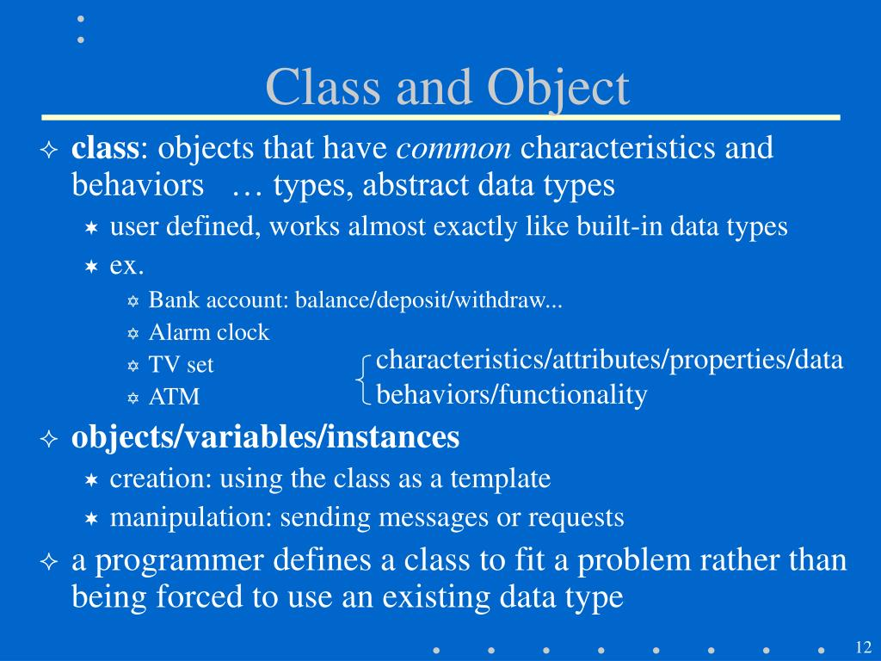
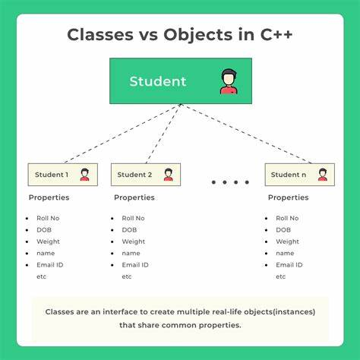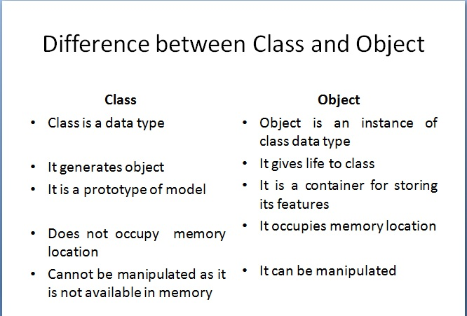

How do you differentiate your priorities in testing?
The purpose of this prioritization is to increase the likelihood that if the test cases are used for regression testing in the given order, they will more closely meet some objective than they would if they were executed in some different order. Some organizations prefer to run “Smoke” or “Sanity” test every time they get a new build or version of the developing software. In this case, test cases will be prioritize based on all the major modules of the software and sanity will be run on them to check the basic functionality for example, in a mobile testing, sanity test suite will have test cases like “restarting the device”, “turning off”, “signing in”, “updating software” etc.
Whether your organization runs regression or sanity or both, Tsest Case Prioritization techniques are applicable for all the cases. Prioritizing test cases can be done on the basis of requirements, costs of bug fixing, history of the parent device etc. Let’s analyze each factor in detail. Some organizations have the practice of categorizing test cases into Blockers, Critical, Major and Minor functionalities.

For this, tester has to understand two major points:
- Understand what product is meant for.
- Who are the users?
Based on above points you know how to keep test cases in following categories:
- Blockers: These are the test cases which test the lifeline of the software. Those features without which the software becomes useless. If any of the feature stops working then this will block the further testing and issue has to get fixed on priority. For example, if a software fails to start then you cannot carry on any testing and product is of no use to the customer.
- Critical: This will have all the test cases related to all the major functionalities performed by the software keeping in mind how users are going to use it. These functionalities are very important to the customer and if these fail then customer will trash the software so they also need to be fixed ASAP to avoid huge loss in business.
- Major: These are the ones which makes our software unique in the market and different from competitors. If these stops working, customer will be unhappy but will still use the software as all the critical features are working fine. They are also important after blockers and critical test cases as this can lead to loss in business as well.
- Minor: In this category, all the suggestions, and small UI changes or product improvements will be included. They will not affect the software usage in anyway and can be avoided if there is tight deadline.

Which do you prefer the most- manual testing or automate testing?

It depends upon the test scenario but I will prefer automation testing as Automated testing is generally much faster and more reliable as a machine does it, whereas manual testing is prone to errors. However, which to use will depend on your test scenario. For example, manual testing is appropriate for usability, ad hoc, and exploratory testing, while regression, load, and performance tests thrive on automation
Testers use methods like automated and manual testing to test software applications. They both have their benefits, but which is easier? Automated testing, for the most part, offers faster turnaround times and less labor-intensive work than most manual tests. These tests allow your computer to perform all of the manual testing without the worry of making mistakes. Further, the tests catch and fix bugs quickly which helps build your company's confidence.
11 )What are your strength and weakness in your work enviroment?

Strengths:
- I consider my leadership skills to be one of my greatest strengths. During my time as a department head, I successfully merged two teams and organized training programs for all team members to ensure that everyone was confident in their new role. As a result, we were able to increase sales by 5% within our first month as a new team.
- Thanks to my experience as an HR representative, I have gained excellent communication skills. I was responsible for facilitating informational workshops for staff members and mediated any conflict in the workplace. I have also completed a course on effective communication from UCLA.
- I have 5 years of experience as a copywriter and consider myself to have strong writing skills. I was promoted to an editorial position after five years at the company, so I have also improved my editing skills thanks to my new role.
- I am very honest. When I feel that my workload is too large to accept another task, or if I don't understand something, I always let my supervisor know.
- My people skills are my greatest strength. I find it easy to connect with almost anyone, and I often know how to empathize with others in an appropriate way.
- Communication skills.
- People skills.
- Writing skills.
- Analytical skills.
- Honesty.
- Leadership skills.
- Patience.
- Writing skills.
- Empathy.
- Initiative.
- Self-motivation.
- Computer literacy.
Weakness :
I mainly used Python in my last position, so I don't have as much experience with Java. I did a course on Java for one semester at University, but I haven't used it since then.
Shyness is something that I struggle with in large groups. I find it intimidating to ask questions or raise points, so I have often remained quiet in the past. I have been trying to be more vocal in smaller groups to become more confident.

3. Have you work on azure devops ? What is azure devops?
4. Have you work on visual studio?
6. Are you comfortable doing api testing both manuel as well as automation?

Technical screening questions:
Principal of agile

4. When you sent error or bad code which response will you get?
11. Where do you store data in local repository in your previous project?
9. How good are you in java

Questions from interview
1. Roles and responsibilities
2.

Bikram Khanal- Zobra, [3/12/2023 2:37 PM]
What is the difference between serialization and de- serialization on java
3. Define method overloading and find the invalid code on the piece of code he gave
4. Why you prefer selenium for automation
5. Have you got the chance to create the framework from the scratch
6. Difference between testng and junit and which on you prefer and why ?
7. What is auto it that is on my resume tell me more about it,
8. How do you manage the waiting time on selenium ?

Questions
1. Tell about yourself.
2. Current roles and responsibilities
3. How do you test api and methodologies used in testing?
4. Which framework are you familiar with?
5. How do you lead the team?
6. What is sdlc
7 what is stlc and process?
9 why do you choose this leading role ?
10. How do you manage if you have 100 bugs in a software?

Technical interview question

1. Tell me about your current role and responsibilities
2. Rate your knowledge of java in the scale of 1-10
3. Explain about api testing
4. Explain about testng annotations.
5. Difference between / and // in xpath
6. Difference between findelement/findelements
7. Explain oops concept in java.
8. What are challenges in test automation?
9. Explain the framework you are currently using.
10. Code... Please explain how you implement the following logic.

Maximum number of occurrence of an character in the given array (no need to write code)
char [] arr1={3,1, 'a', 'b', 'c', 'c', 'd',1, 'c'}

technical interview questions
1. What tools are you using in your current project?
2. What is agile framework? How do you work in it?

=>An Agile framework is a specific approach to planning, managing, and executing work. Agile frameworks typically fall into two categories: Frameworks designed for teams, and frameworks designed to help organizations practice Agile at scale, across many teams.

Popular Frameworks
- Scrum
- eXtreme Programming (XP)
- Dynamic Systems Development Method (DDSM)
- Feature Driven Development (FDD)
- Adaptive Software Development (ASD)
- The Crystal Method
- Lean Software Development (LSD)
- Disciplined Agile (DA)
- Scaled Agile Framework (SAFe)
- Rapid Application Development (RAD)
With so many different approaches to structuring agile processes within your organization, you’re probably wondering how to go about choosing one. Unfortunately, there is no one-size-fits-all way to practice agile software development. Many factors may influence which framework you choose to work with. Such as:
- Company size
- Team structure
- Available resources
- Needs of stakeholders
- Structure/size of your product portfolio

=> It focuses on breaking down large projects into more manageable tasks, which are completed in short iterations throughout the project life cycle. Teams that adopt the Agile methodology are able to complete work faster, adapt to changing project requirements, and optimize their workflow.

Agile methodologies take an iterative approach to software development. Unlike a straightforward linear Waterfall model, Agile projects consist of a number of smaller cycles – Sprints. Each one of them is a project in miniature: it has a backlog and consists of design, implementation, testing, and deployment .At the end of each Sprint, a potentially shippable product increment is delivered. Thus, with every iteration new features are added to the product, resulting in gradual project growth. With the features being validated early in the development, the chances of delivering a potentially failed product are significantly lower.

4. How do you type text in text box in selenium?
5 . What are xpaths and css selectors?
6. About web elements.

1. Describe your current roles and responsibilities.
2. Explain your framework
3. How would you find login text box
4. Tell me about api testing you have done.
5. How comfortable are you with javascript code?
6. How would you ensure the application you have tested is of highest quality?
7. How would you report a bug and what tool would you use to report it?
8. How would you determine what functionality to automate?

General discussion
1. What are the tools you used
2. How to write test cases
3. Which framework you are familiar
4. Testing process and
5. What is git

general discussion
Have you worked on web services?
Have you worked on api?
Tell me about contract in postman?
What is meant by term environment with respect to postman ?
Tell me about various authorization method in postman ?
How do you write the test scripts?
Tell me your daily work process?
What is your salary expectations?

Tell me about yourself
2. Did you find any defect while doing testing and what is your favorite defect
3. Do you know how to fix that defect
4. Describes performance testing you did
5. How strong are you with linux backend
6. How do you know the pords are open in linux
7. Do you have experience in cloud
8. Have you use docker
9. Different between vm and container

technical resource required for attending classes and interviews
1. Window laptop with processor i5 or higher. Laptop should come with both audio and video feature.
2. Internet speed should be greater than 250 mbps.
3. Camera, speaker, microphone of pc should be excellent.
4. Student phone should have 100% network coverage

general requirements at the time of marketing:
1. Expert on zoom, ms-team, goto meeting (basically meeting apps)
2. Formal dress during the office visit and during the interview.
3. Smiley face during interviews
4. System should be restarted 2 hrs before interviews.

1. Explain your current project and your roles and responsibilities.
2. How do you find duplicate record in a table?
3. How do you remove duplicate records in a list, collection?
4. Why would you have different folders in a testing framework?
5. Give some examples of cucumber annota

Bikram Khanal- Zobra, [3/12/2023 2:38 PM]
tion.
6. What is run time polymorphism?
7. Why would you use interface?
8. How would you handle the software deliverables when there is time constraint?
9. What are the chanllanges you faced as qa engineer?
10. What is the difference between union and join in sql?
11. Difference between list and set in collection?
13. Define priority and its order of execution in testng annotation.
14. Expalin try catch and finally in java exception handeling.
15. Explain pom?
16. Why would you use selenium webdriver as automation tool?

Technical interview

1. Cucumber bdd annotations.
2. Difference between scenario and scenario outline
3. How do you set up testng framework?
4. How do you compare two arrays? ?
5. How do you skip any test case in testng framework?
6. How do you find max salary in a table using sql statement?

General discussion:
1. Introduce yourself
2. How do you write test cases using selenium
3. How do you break api testing
4. Have you done testing beyond happy path

questions
1. What is your strength and weakness
2. What are the advantage of remote and on-site work
3. What is different between contacts job and direct hired
4. How you handle conflicts at work can you give us examples
5. What are the things you expect from your senior
6. What is main difference between agile and water fall model why. And which one is best can you explain
6. How you connect with your team members
7. How many team members do you have , how may dev team and how many testing team
8. How you connect with po
9. What is retrospect meting what you do and when you do
10. How you learn new things
interview questions- screening
1. Current role and responsibilities.
2. Brief explanation of oops concepts
3. Do you have any knowledge on aws.
4. Knowledge in jenkins.
5. How comfortable are you with java programming?

Technical questions
1. Write a code in codility to make two array random numbers in one array in ascending order.
2. Write any codes for showing hashmaps.
3. Do you know restassure?
4. Show the framework of your current projects.
5. What are the different tools used in current project.
6. Have you use api, postman?
7. What percentage of manual and automation are you using in your current project?

General discussion:

1. Tell me about yourself
2. Tell me your role in current position
3. Where do you use postman in your project
4. Do you have experience with micro services
5. What tool you use for automation and manual testing

questions
1. How would you manage your team as team leader
2. Have you ever given feedback to your team
3. Have you ever get feedback and what is the feedback you get
4. How many team members you have in your team in cottonwood and also in averest bank
5. In what project you work in cottonwood and in averest bank

from yesterday interview questions
tell about yourself and current project
your roles and responsibilities
tools and technologies for automation your are familiar with
about relocation
have you got chance to work from scratch on testing framework
are you familiar with c# language
differences between c# and java
have you done performance testing

questions
1. How would you manage your team as team leader
2. Have you ever given feedback to your team
3. Have you ever get feedback and what is the feedback you get
4. How many team members you have in your team in cottonwood and also in averest bank
5. In what project you work in cottonwood and in averest bank

general discussion
1. Can you write script
2. Tell me how you write script
3 why looking for new position
4. Give me your. Last 4 digits of your social security
5. Are you eligible to work in us
6. Do you have experience in mobile testing, bugging

general discussion
1. Can you write script
2. Tell me how you write script
3 why looking for new position
4. Give me your. Last 4 digits of your social security
5. Are you eligible to work in us
6. Do you have experience in mobile testing, bugging

interview questions
1. Introduce yourself
2. What are the tools you use for automation and API testing?
3. How many team members do you have?
4. How do you create json response? Questions was given.
5. Suppose if you find defect before the release, how do you handle it?
6. Automation and api, which one do you prefer and why?

Interview questions
1. Can you explain your day to day job ?
2. Which programming language your comfortable and have you work with c#
3. Explain current project framework
4. Do you have any conflict with your co-works
5. Do you follow scrum

interview questions
1. Give me brief about yourself.
2. Have you use cypress?
3. How do you automate search bar using selenium?
4. What do you like most about java and what you dont like about it?
5. Explain me how do you join the 2 tables using sql.
6. Questions about frame work

general discussion
1 what is ed diagram , can you explain
2. What is agile
3. What is quality , why it is so important
4. Tell me about yourself

interview questions
1. Tell be about yourself.
2 what is your role in your current project.
3. Explain about the framework you have used.
4. Describe complete process of testing.

General discussion
what tools you are using in all your previous companys
2 whats your date of birth
3. Do you need work authorization or sponsorships
4. Are you okie with this pay rate
5. Have you done mobile testing

general discussion
1. Why are you changing your job?
2. What are your roles and responsibilities in your current project?
3. Are you willing to relocate?

Technical general discussion
1. How would you like to introduce yourself
2. What is static method
3. Are you comfortable working with c#
4. Are you comfortable with api testing as well
4. Did you talk with our hr team about compensation
5. Why are you looking for new job
6. What will the compiler do if you dont declare constructor

tell me about yourself
2. What is bdd and how you use it with cucumber
3. What is the difult value of arraylist
4. Where does the object stored
5. What are different types of x path
6. Where and why you use index selector
7. Why we use css selector
8. Have you developed frame work from scratch
9. Prerequisites for frame work development
10. Challenge you face and want to solve it

Bikram Khanal- Zobra, [3/12/2023 2:41 PM]
Hello All, plz find the Interview questions and plz correct the grammar as needed

Bikram Khanal- Zobra, [3/12/2023 2:41 PM]
General discussion (1 hour)
whta is tester responsibilities?
What is mean by Maven?
what is capsulation?
what is inheritation?
Do you have any challenge you face in work?
What is mean by JAWS,Jmeter,jira, from resume?
How and who can decide ,which project you need to to manual or automation?
Why you move to United State?
What is your current job duties and responisilities?
Do you have any tester certificate?
What is SQL to get total counts from employee table?

Bikram Khanal- Zobra, [3/12/2023 2:42 PM]
General Discussion
1. explanation about their company

3. How comfortable are you in automation part
4. How many percentage would you say for manual and automation testing
5. Are you comfortable in hybrid working model?
6. Salary
8. How many experience in automation testing?
9. Do you only execute testcases or do you develop code too?

Bikram Khanal- Zobra, [3/12/2023 2:42 PM]
41. Explain exception hirerchy
42. Difference between exception and error
43. Runtime exception and compiletime exception
44. Use of try block
45. Can we write multiple catch block
46. Which on is better , to write multiple catch or single catch
47. Which strategy we need to remember if we want to use multiple catch block
48. Purpose of finally
49. Tell me one scenario where finally block will not executed
50. How we can write custom exception
51. When to use throw and throws . Explain
52. Why we need to handle exception
53. Explain exception propagation
54. Name couple of error that you have encountered in current project
55. Class not found , number format exception explain
56. What we need to do if any errro occurs
57. Try followed by finally is possible?
58. Does finally block can handle exception
59. What is try with resources . Example and explain. Benefit of it.
60. Use of finally block in your current project with explanation

Bikram Khanal- Zobra, [3/12/2023 2:42 PM]
61. Difference between arraylist and linkedlist
62. How arraylist works internally
63. Explain basic characteristics of arraylist
64. Explain basic characteristics of linkedlist
65. Explain different methods used in arraylist and linkedlist
66. When we should use arraylist and when use linkedlist
67. Default size of arraylist
68. How linked list works internally
69. Explain set and it's characteristics
70. Set vs shorted set
71. How to remove duplicate values from arraylist
72. Explain Map and it's implementation
73. When to use Map
74. How to add values in hashmap with program
75. What is iterattor in java . Wirte iterator program and explain in detail
76. How to iterate Map . explain with code
77. How to get a value in Map
78. How hashmap works internally
79. How to sort data in arraylist
80. How to sort objects in java . Explain in detail
81. Write sorting program of comparator and comparable interface
82. Relation between hashcode and equals method
83. What is hashtable and how it works internally
84. What is concurrent hashmap and how it works
85. Is hashmap thread safe . Explain

Bikram Khanal- Zobra, [3/12/2023 2:43 PM]
86. What is String in Java
87. How many way we can create string. Explain in detail
88. How many objects will create in case of object create using strong literals
89. Equals() vs ==
90. What is stirng constant pool
91. Explain different Sting methods
92. String buffer vs String builder
93. How to convert String to array
94. Why String is called immutable
95. How we can create our own immutable class
96. In String is data type or class
97. Difference between String contant pool vs heap area
98. Final vs finally vs finalize
99. What is synchronisation in java
100. What is Thread and how we can create a thread. Explain in details

Bikram Khanal- Zobra, [3/12/2023 2:43 PM]
Difference between regression and smoke testing
Difference between abstraction and interface
In manual testing what did you test?
Different type of functional testing
Do you know about maven?
Which framework did you used
About ResT, API testing
Difference between private public and protected
Tell me something about POST
How would you rate yourself on Java out of 10?
How do you handle Pop up on browser
Have tested mobile application
How do you execute the test cases?
Jenkins question

can you tell me some test cases if you were to write one on," gear shifting of vechile"
have you had experience on working on AWS? or any such.
have you had experience on working on unix/ linux? becuase i see that one in your resume
command related to unix/linux
what do you know about the differences in UI,API and Unit testing?
if you were too chose and prioratize, which one would you chose and why?
do you know about coderpath? and then,he tells me to write a code on that. "write a code for reversing a string"
Have you been actively seeking for jobs in other companies? could you please update me on that.

3. Do you have any knowledge on testing desktop applications?
4. Are you familiar with C#, visual basics or python?
5. What are Xpath and Css locators? Whats the difference?
6. Have you had any problem while locating web elements ? what are they?
7. What can you say about soak testing?
8. What kind of performance testing have you done?
9. We don't require website testing but Are you interested to work on embeded system/Car manufacturing for web application testing?
10. How confident are you about your skills on web automation?
11. How good are you with SQL? Any experience with backend testing?

5. Do you have any knowledge on Springboot framework?
6. What is static keyword in java? When can you use it?
7. Do you need to create an object to call a static method? How do u call it?
8. What is interface in java? Why do you use interface?
9. What is the difference between list interface and set interface?
10. Where do you use list and where do you use set?
11. Tell me about REST API.
12. Where have you used Assertions for adding dependency in REST API in your project? How do you do it?
13. Page Object Model and Page Object Model?
14. How do you use test estimation?

https://www.sam-solutions.com/blog/what-are-the-estimation-techniques-in-software-testing/

How to answer interview question “You find a major bug, but no developers are present. What do you do?"

https://sqa.stackexchange.com/questions/31289/how-to-answer-interview-question-you-find-a-major-bug-but-no-developer1.s-are-pr

What Should be Done After a Bug is Found?
https://www.ajonit.com/software-testing/bug-is-found-tester-job/#:~:text=found%2C%20a%20tester%20is%20required,exact%20failure%20of%20the%20software.

